

Cyberster Internship Program

Internship Report
TRACK: BLUE TEAM
NAME: MUHAMMAD RAZA
ROLL NUMBER: CSI-B1-121
WEEK 2: DETECTION, CUSTOM RULES, AND LOG ANALYSIS

TABLE OF CONTENTS

Overview 5
Days 8 and 9 — File Integrity Monitoring (FIM) 5
Linux FIM Configuration and Testing (Day 8) 5
Windows 10 FIM Configuration and Testing (Day 9) 7
Days 10 and 11 — Custom Detection Rules 10
Rule 1: New User Creation 10
Rule 2: SSH Brute Force 11
Rule 3: Unauthorized USB Insertion 13
Days 12 and 13 — Log Analysis Fundamentals 14
Log Analysis Breakdown 14
Timeline of Suspicious Activity 18
Day 14 — Wazuh Active Response 19
Configuration Workflow 20
Attack and Verification 21
Risks and Safeguards of Active Response 22

Overview
Week 2 transitions the SOC environment from a passive logging infrastructure to an active detection and response platform. The objective of this week was to configure real-time File Integrity Monitoring (FIM), engineer custom detection rules to catch specific MITRE ATT&CK techniques, perform deep-dive log analysis across Linux and Windows environments, and finally, implement automated Active Response to dynamically block attackers at the OS firewall level.

Days 8 and 9 — File Integrity Monitoring (FIM)
File Integrity Monitoring (FIM) is critical for detecting unauthorized modifications to system files, configuration files, and critical directories.

Linux FIM Configuration and Testing (Day 8)
To monitor the critical /etc directory on the Kali Linux agent, I modified the local ossec.conf file.
Step-by-Step Execution:
- Opened the agent configuration file: sudo nano /var/ossec/etc/ossec.conf
- Added the directory to the <syscheck> block with real-time reporting enabled:
<directories realtime="yes" report_changes="yes">/etc</directories>
- Set the syscheck frequency to 300 seconds.
- Restarted the Wazuh agent to apply changes: sudo systemctl restart wazuh-agent

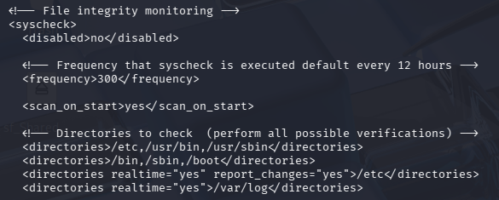
The Attack & Verification:
To test the configuration, I simulated an attacker establishing persistence by creating, modifying, and deleting a file in the /etc directory.
- Command 1: sudo touch /etc/hacker_test.txt
- Command 2: echo "Attacker persistence established" | sudo tee /etc/hacker_test.txt
- Command 3: sudo rm /etc/hacker_test.txt
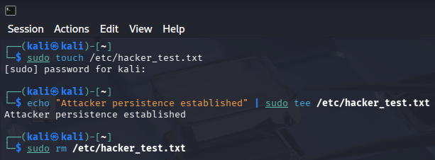
The Wazuh Dashboard immediately caught the modifications, triggering Level 7 "Integrity checksum changed" alerts for the Kali agent.
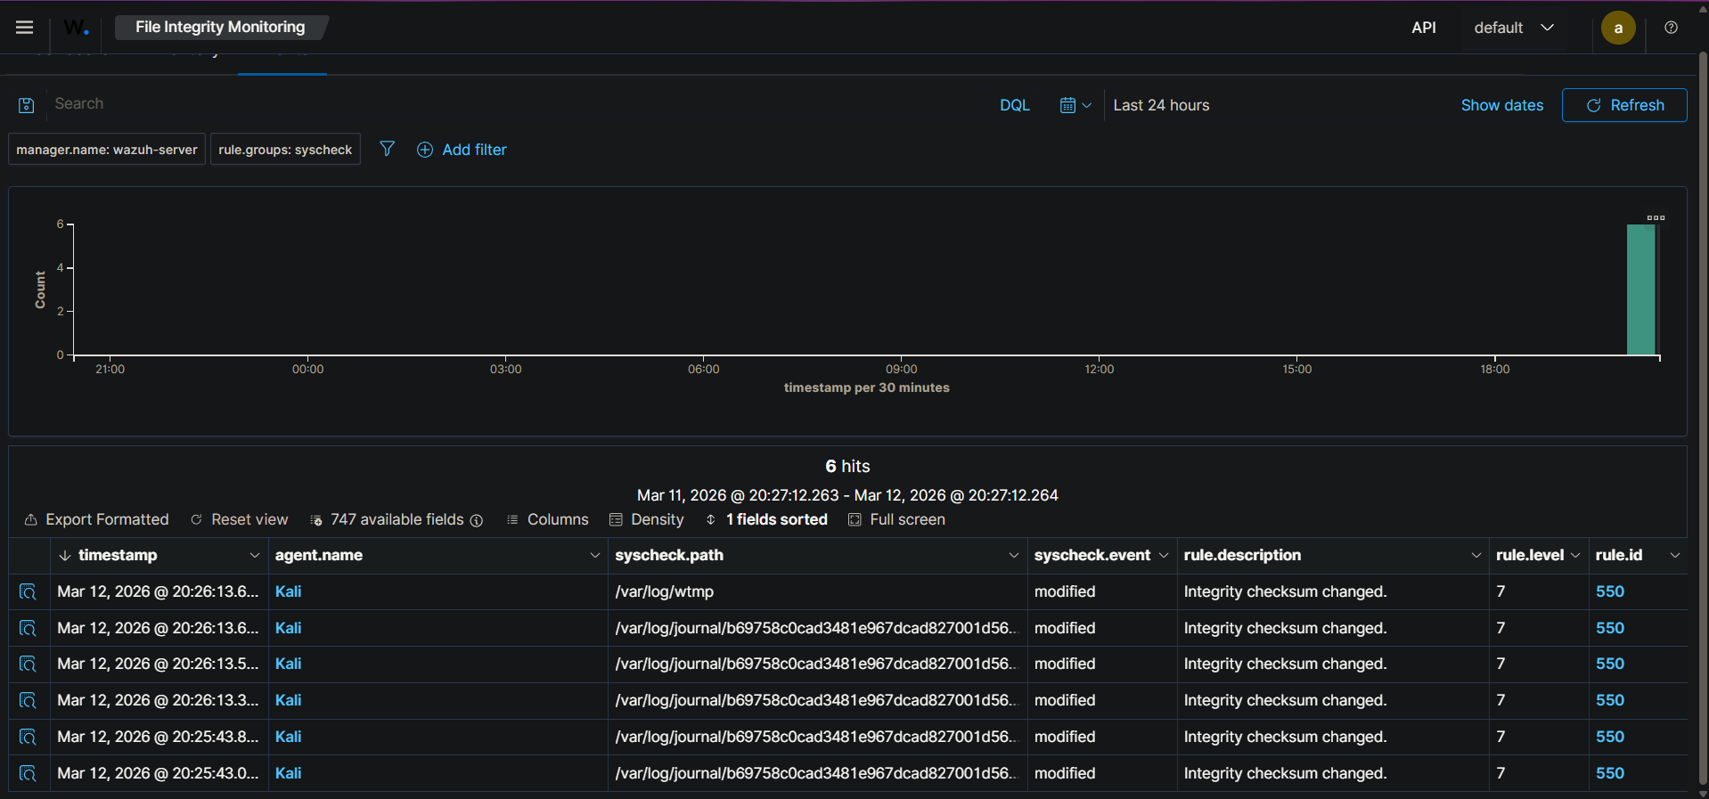

Windows 10 FIM Configuration and Testing (Day 9)
I repeated this process for the Windows 10 endpoint, specifically targeting the C:\Windows\System32 directory where malware often drops malicious payloads.
Step-by-Step Execution:
- Opened C:\Program Files (x86)\ossec-agent\ossec.conf using Notepad as Administrator.
- Configured the <syscheck> block:
<directories realtime="yes" report_changes="yes">C:\Windows\System32</directories>
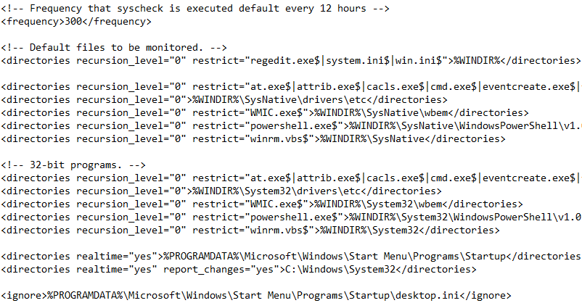
- Restarted the Wazuh Windows Agent via services.msc.
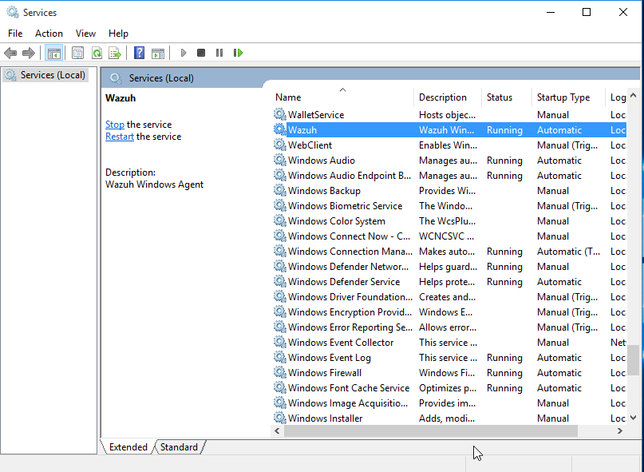

The Attack & Verification:
Using the Windows Command Prompt, I simulated a malware payload drop:
- echo "Malicious payload dropped" > C:\Windows\System32\hacker_test.txt
- echo "Updating payload" >> C:\Windows\System32\hacker_test.txt
- del C:\Windows\System32\hacker_test.txt
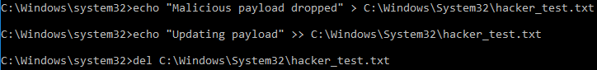
Wazuh successfully captured these events. Expanding the JSON data revealed the exact SHA256, MD5, and SHA1 hash changes of the modified files.
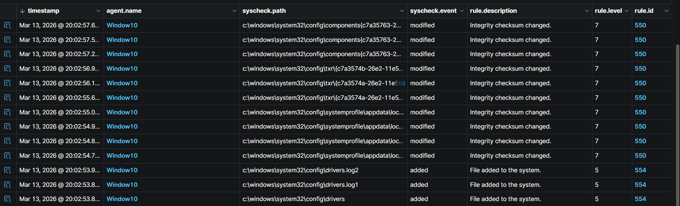
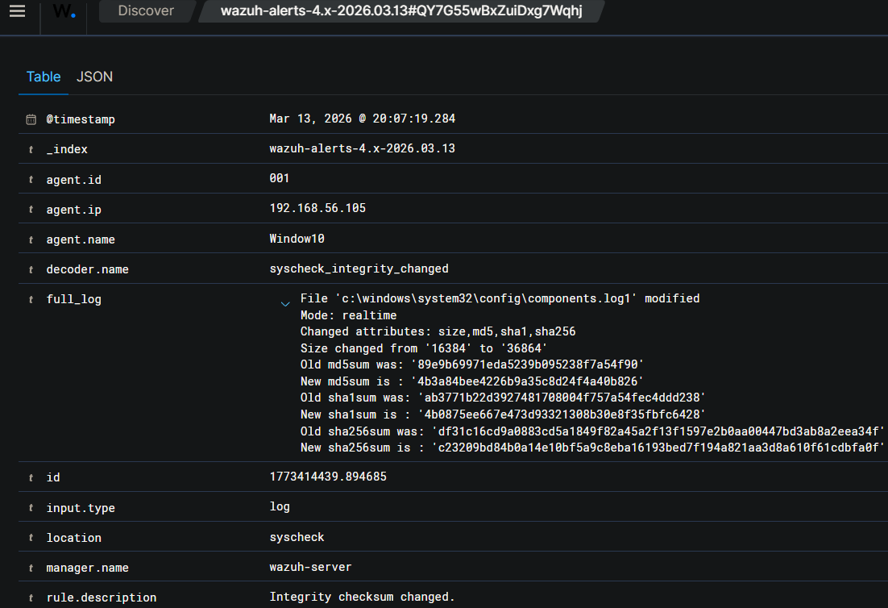

Days 10 and 11 — Custom Detection Rules
Default SIEM rules are often noisy or insufficient. These tasks required engineering custom XML rules to detect specific attacker behaviors mapped to the MITRE ATT&CK framework.

Rule 1: New User Creation
To detect unauthorized persistence, I wrote a custom rule (ID 100010) to trigger a Level 10 Critical alert whenever a new user account is created on a Linux system (T1136).
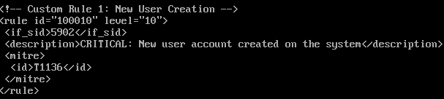
Verification: I executed sudo useradd darthvader on Kali. The rule triggered perfectly.
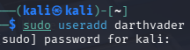
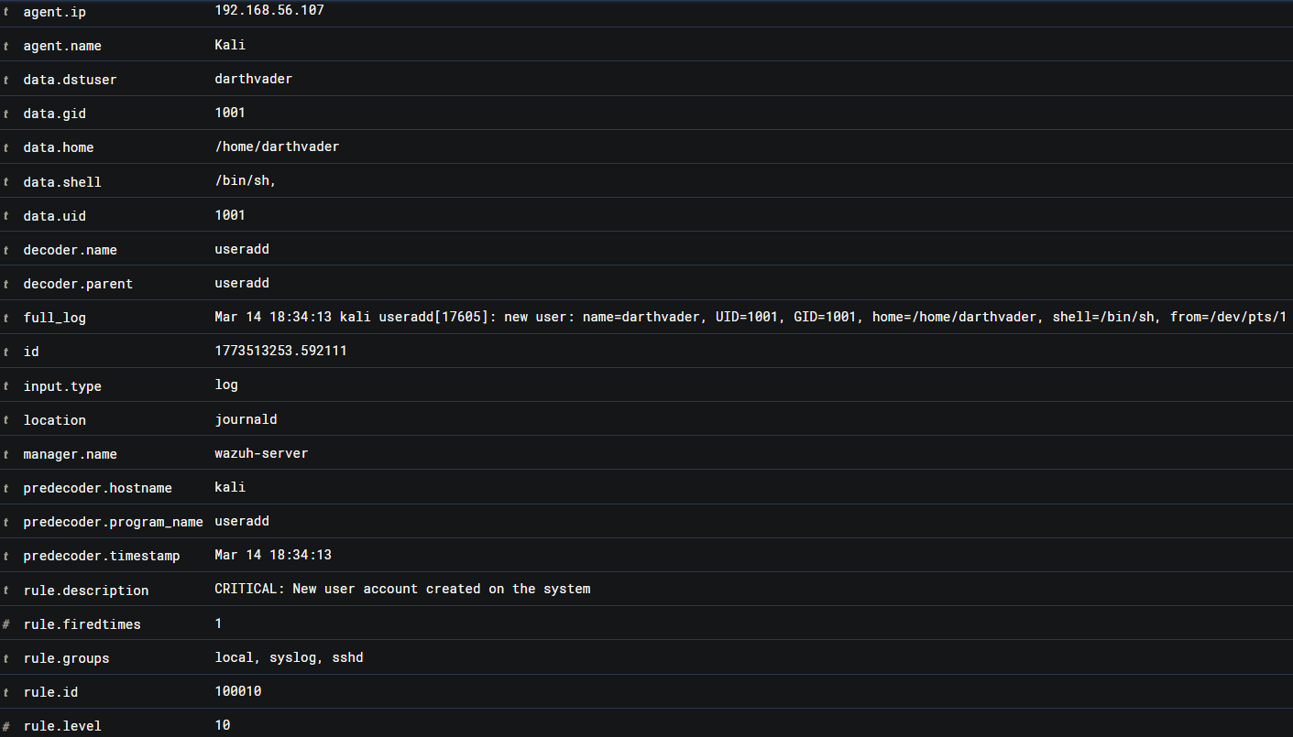

Rule 2: SSH Brute Force
To detect credential stuffing, I created a frequency-based rule (ID 100011). It triggers a Level 12 alert if 6 authentication failures (<if_matched_sid>5760</if_matched_sid>) occur from the exact same source IP within a 120-second timeframe (T1110.001).
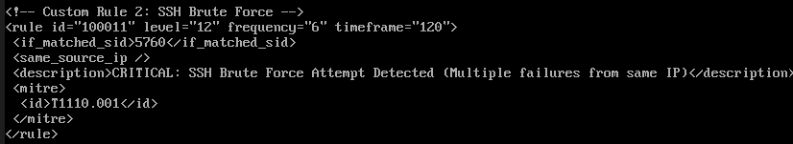
Verification: I spammed the SSH login prompt with incorrect passwords. Wazuh grouped the events and fired the Level 12 Critical alert.
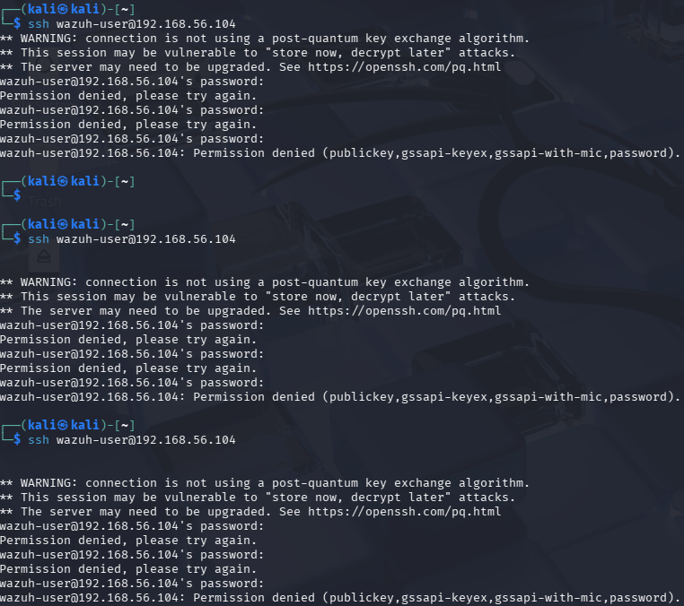
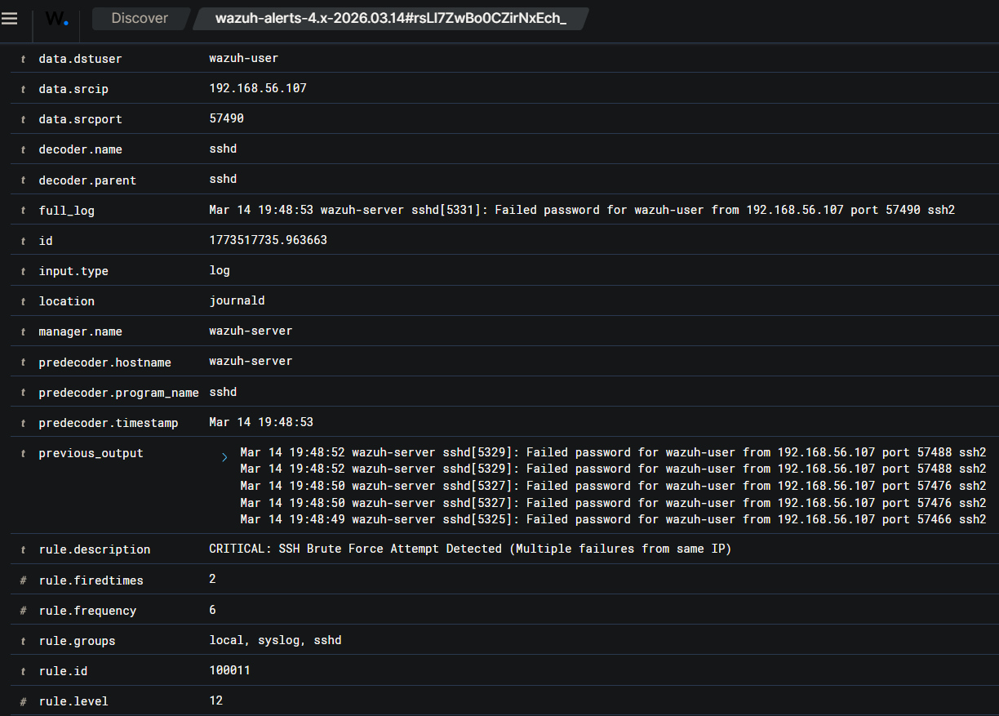

Rule 3: Unauthorized USB Insertion
To detect physical data exfiltration (T1052), I created Rule 100012 to upgrade standard USB mounting logs into a Level 8 Warning.
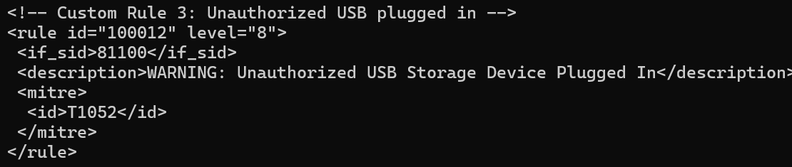
Verification: Due to agent-side OS logging limitations, I utilized the backend wazuh-logtest engine to prove the rule logic. Injecting a raw kernel USB log successfully fired Phase 3 of the testing engine, confirming the rule's operational status.
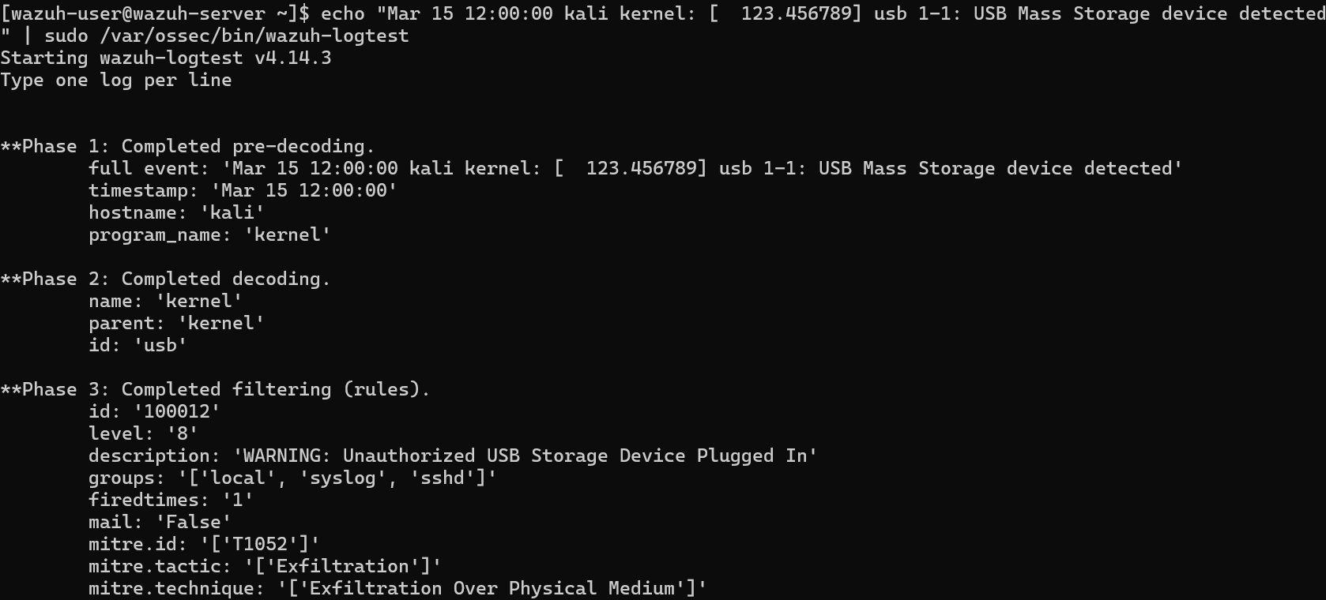

Days 12 and 13 — Log Analysis Fundamentals
Log analysis is the core of incident response. This phase involved querying the SIEM to correlate events across multiple agents and identify the "who, what, and when" of a security incident.

Log Analysis Breakdown
Source OS: Linux
Event / Rule ID: Wazuh Rule 5760
Trigger Activity
Multiple sshd: authentication failed events for wazuh-user from 192.168.56.107.
Analyst Interpretation
Deliberate Attack: The frequency and volume of these failures indicate a targeted SSH Brute Force attack, not a routine typo.
Screenshot Evidence
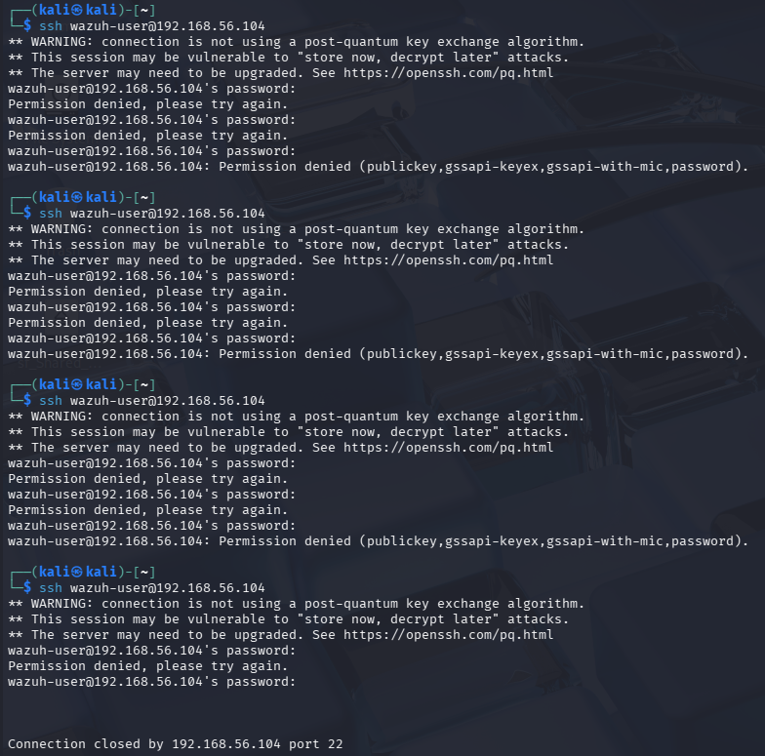
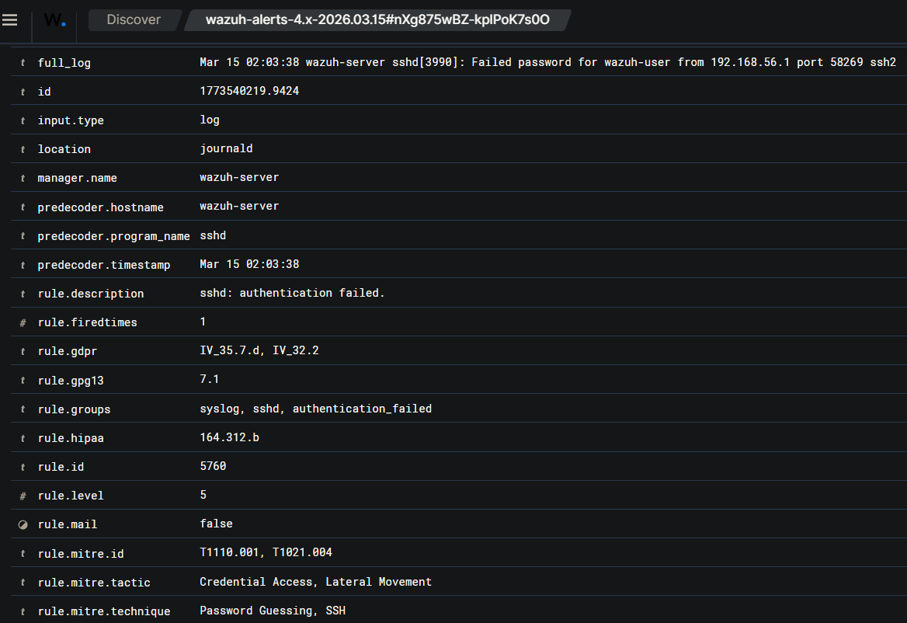

Source OS: Windows
Event / Rule ID: Event ID 4672
Trigger Activity
Elevated Command Prompt assigning special privileges to a logon session.
Analyst Interpretation
Suspicious if Unplanned: Routine if done by a known Admin, but highly suspicious if correlated with a prior brute-force alert.
Screenshot Evidence
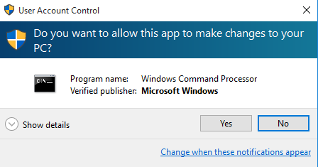
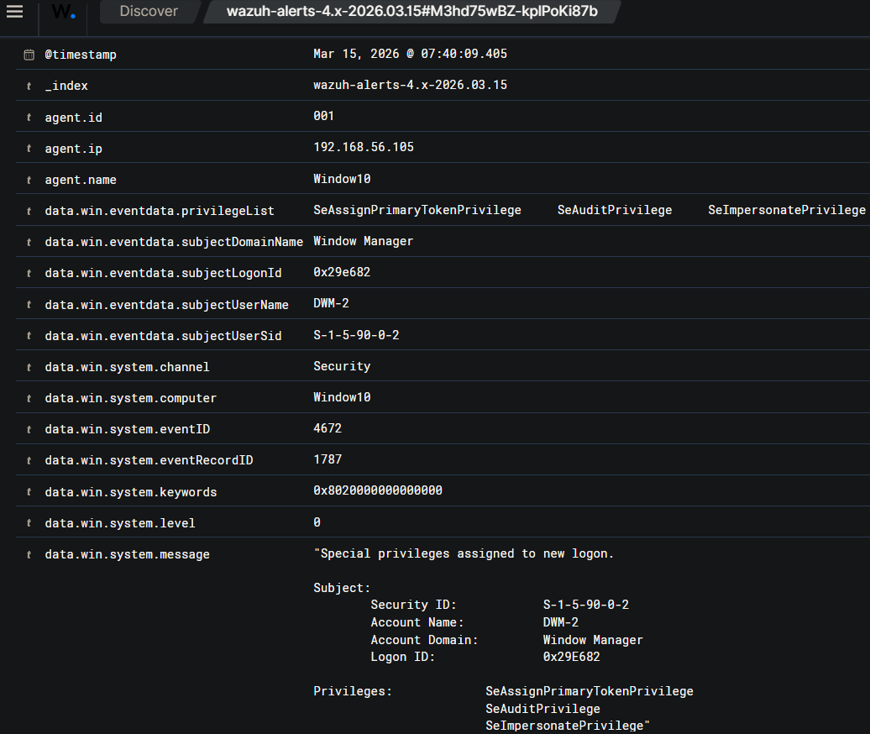

Source OS: Windows
Event / Rule ID: Event ID 4720
Trigger Activity
net user SneakyHacker command executed, creating a new account.
Analyst Interpretation
Critical: Active establishment of persistence. The logs identify vboxuser as the creator of SneakyHacker.
Screenshot Evidence
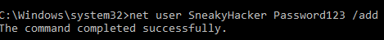
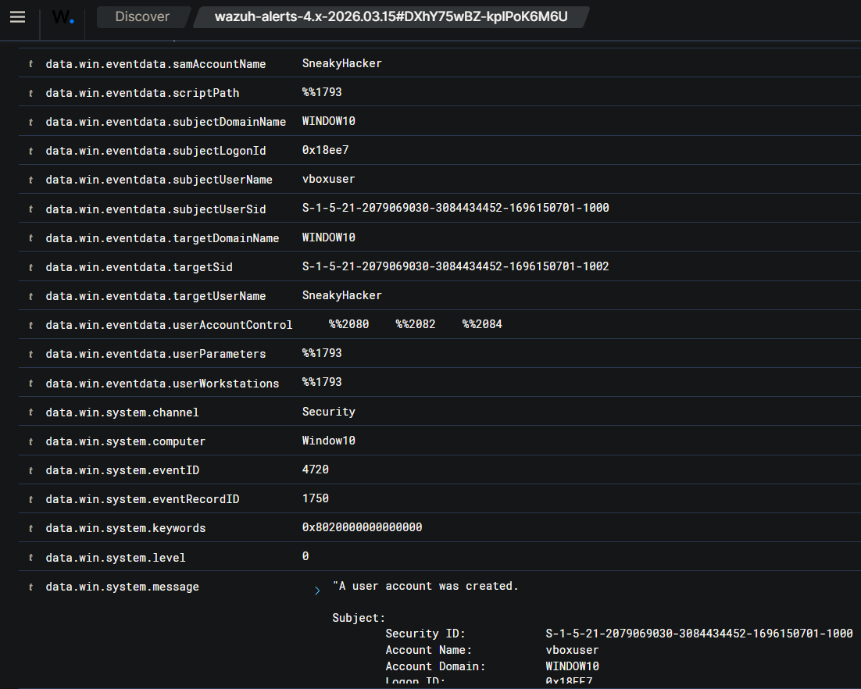

Source OS: Windows
Event / Rule ID: Event ID 4625
Trigger Activity
vboxuser failed logon attempt with SubStatus 0xc000006a
Analyst Interpretation
Routine (Isolated): The specific sub-status code 0xc000006a indicates a bad password was entered.
Screenshot Evidence
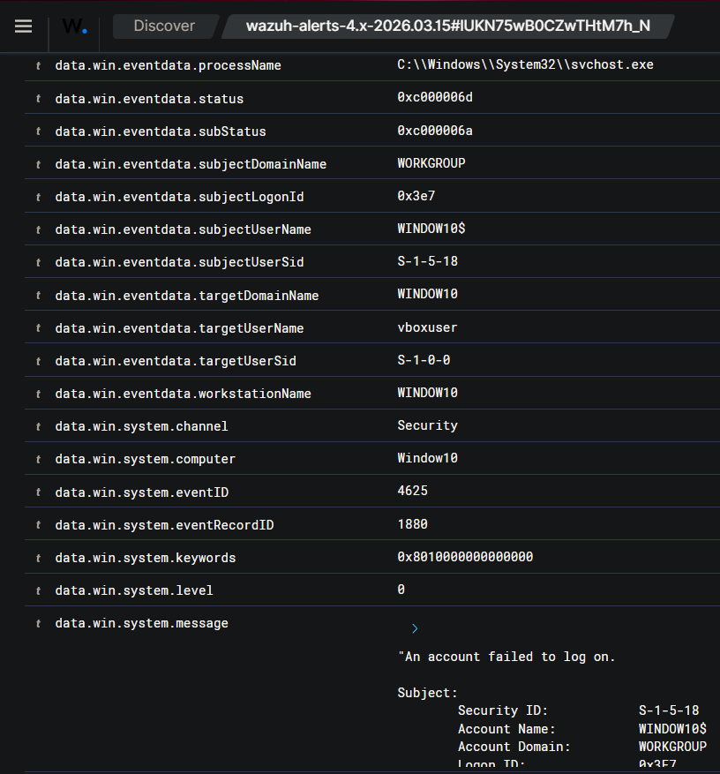

Timeline of Suspicious Activity
The following timeline represents the chronological flow of flagged incidents across the environment.

Timestamp | Event Description | Agent | Analyst Note
Mar 14, 18:34 | CRITICAL: New user account created (Level 10) | Kali | Flagged as potential backdoor creation (User: darthvader).
Mar 14, 19:48 | CRITICAL: SSH Brute Force Attempt (Level 12) | Wazuh-Server | Active credential stuffing attack identified from 192.168.56.107.
Mar 15, 07:34 | User account enabled or created (Level 8) | Window10 | Windows Event ID 4720 triggered; persistence suspected.
Mar 15, 07:40 | Special privileges assigned to new logon (Level 3) | Window10 | Windows Event ID 4672 triggered; potential privilege escalation.

Day 14 — Wazuh Active Response
Active response elevates the SIEM from a passive monitor to an automated defense mechanism. I configured Wazuh to automatically drop traffic from an IP address at the OS firewall level if it triggered the SSH Brute Force rule.

Configuration Workflow
- Adjusted Custom Rule 100011 to trigger exactly on 5 failed attempts (frequency="5").
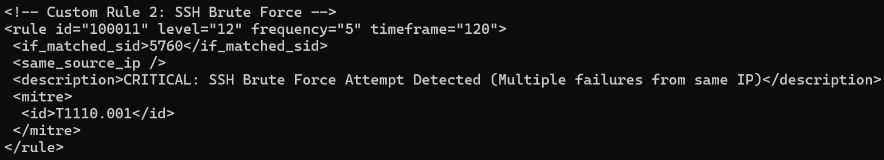
- Backed up the master config: sudo cp /var/ossec/etc/ossec.conf /var/ossec/etc/ossec.conf.bak
- Edited the <active-response> block in ossec.conf to utilize the firewall-drop command. I set the timeout to 300 seconds (5 minutes) for safe testing.
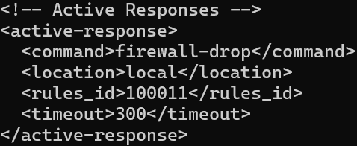
- Verified iptables was installed on the Amazon Linux server to ensure the script could execute properly.
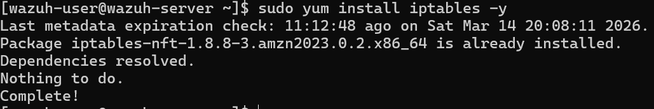

Attack and Verification
I initiated an SSH brute-force attack from Kali. On the 6th attempt, the terminal froze, and the connection was completely refused.

Running sudo iptables -L -n on the server proved that the Wazuh agent had successfully rewritten the host firewall, actively dropping all traffic from the attacker's IP (192.168.56.107).
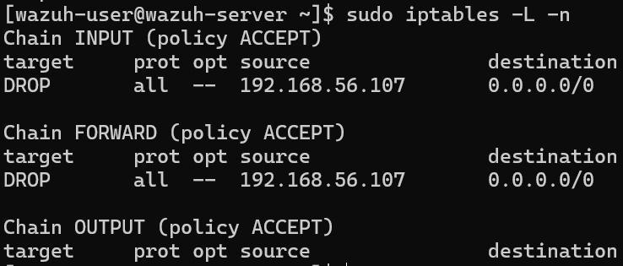
The dashboard confirmed the entire kill chain: Login failures grouped into a brute-force alert, instantly followed by Rule 651 indicating the Active Response execution.

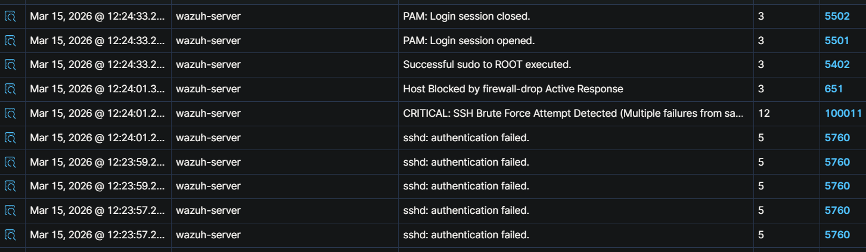

Risks and Safeguards of Active Response
While Active Response is powerful, deploying it in a production environment carries significant operational risk.
The primary risk is a Self-Denial of Service (DoS). If a legitimate administrator forgets their password and attempts to log in multiple times, an overly aggressive Active Response configuration will instantly lock them out of the server. Furthermore, sophisticated attackers can leverage IP Spoofing. By forging their source IP to match a critical internal asset (such as the company's Domain Controller or primary DNS server), an attacker can intentionally trigger the brute-force rule, causing the SIEM to automatically ban the company's own infrastructure and taking the network offline.
Safeguards: Before enabling this in production, strict safeguards must be established. First, a robust <white_list> must be configured in ossec.conf containing all mission-critical IP addresses (Domain Controllers, vulnerability scanners, admin workstations) to ensure they can never be banned. Second, permanent bans should be avoided; using a timeout threshold (e.g., 5 to 15 minutes) ensures that if an accidental block occurs, the system will automatically self-heal and restore access without requiring emergency manual intervention.
End of Week 2 Report

